Chem Project - HTML Program

Topic and Justification

This interactive web application is designed to cover the 3 topics of 3D shapes and properties of compounds, elements in the periodic table and balancing of reaction equations. The design is made to be as interactive as possible such that users can be more engaged, revolutionising conventional learning through textbooks through dynamic representations.

Features and Interactivity
The program integrates 3 core modules: ChemScope (a 3D molecular viewer), Elements (an interactive periodic table), and Equation Balancer. “ChemScope” offers immersive 3D models of chemical compounds, allowing users to input a chemical formula and examine the molecular geometries freely with information about the compound being shown such as bond angle, shape, molar mass. “Elements” lets users click on any element in the periodic table to reveal comprehensive details, including standard state, block and electronic configuration. “Equation Balancer” enables users to input an unbalanced chemical equation and instantly receive a correctly balanced equation.

Learning Outcomes
Not only has working on this project causes us to dive deeper into the use of AI, familiarising ourselves with up-to-date technology, but we also revised our chemistry knowledge, such as shape of molecules, while exploring elements we do not usually come across in past papers, for instance, lanthanides and actinides.

Screenshots (ChemScope)

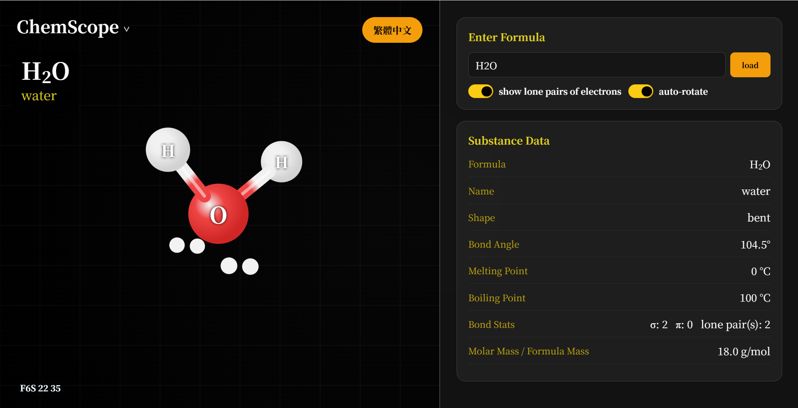
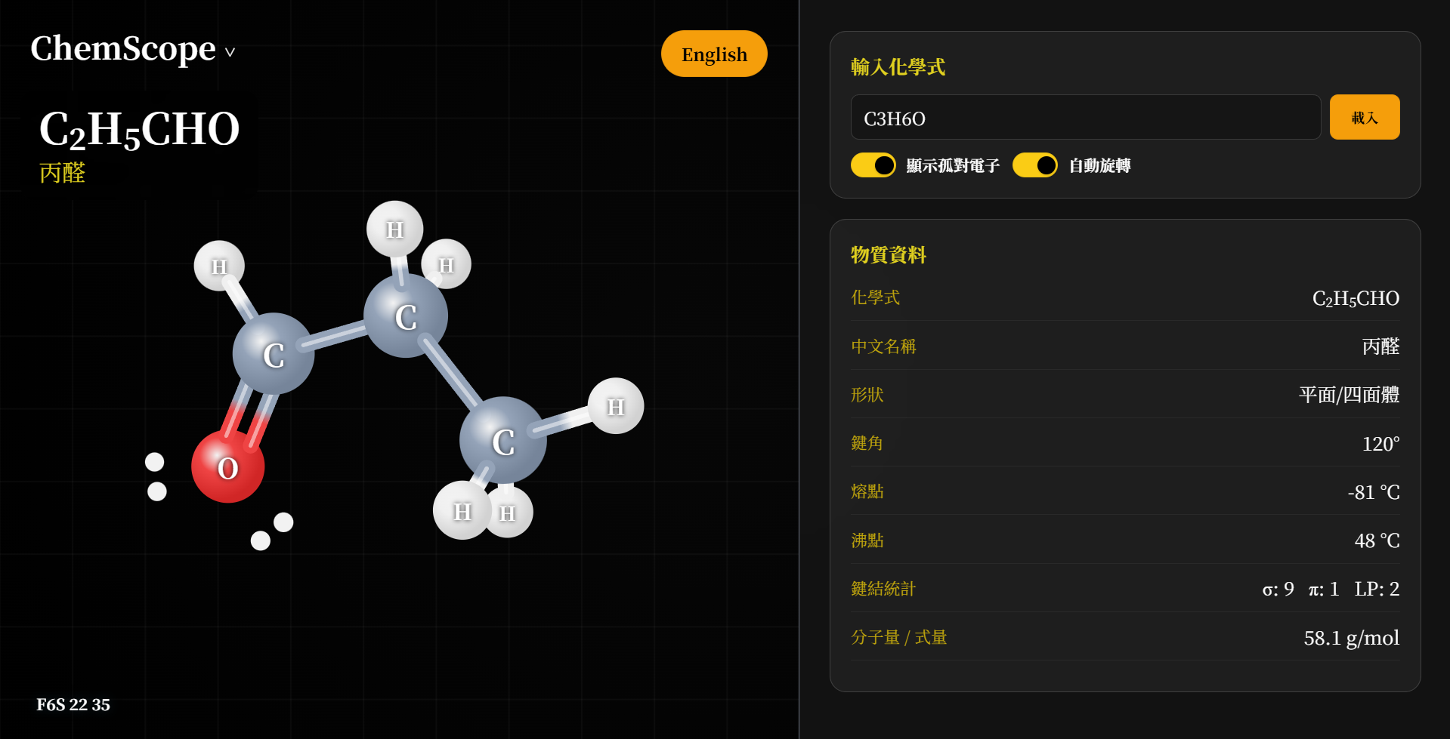

Screenshots (Elements)

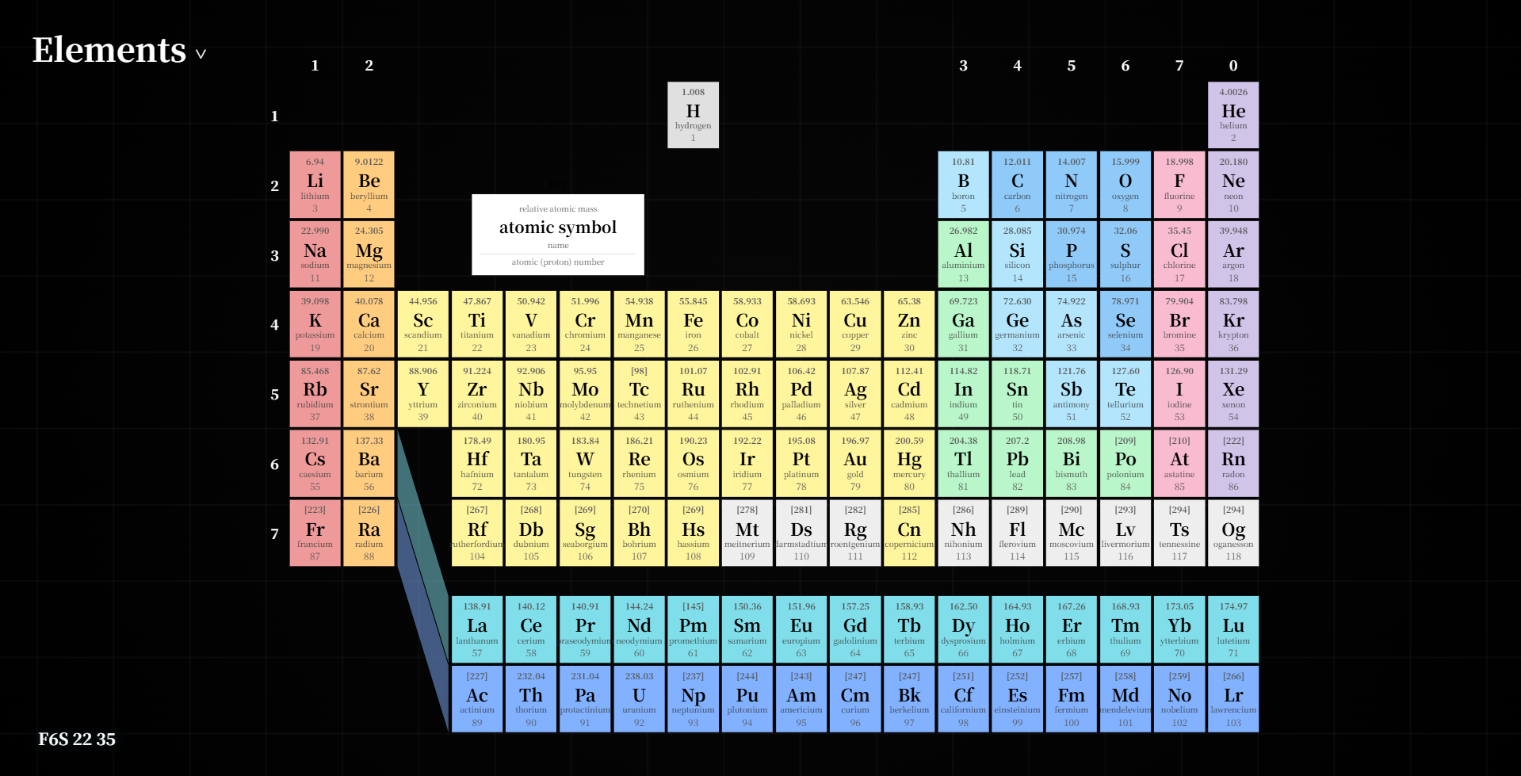
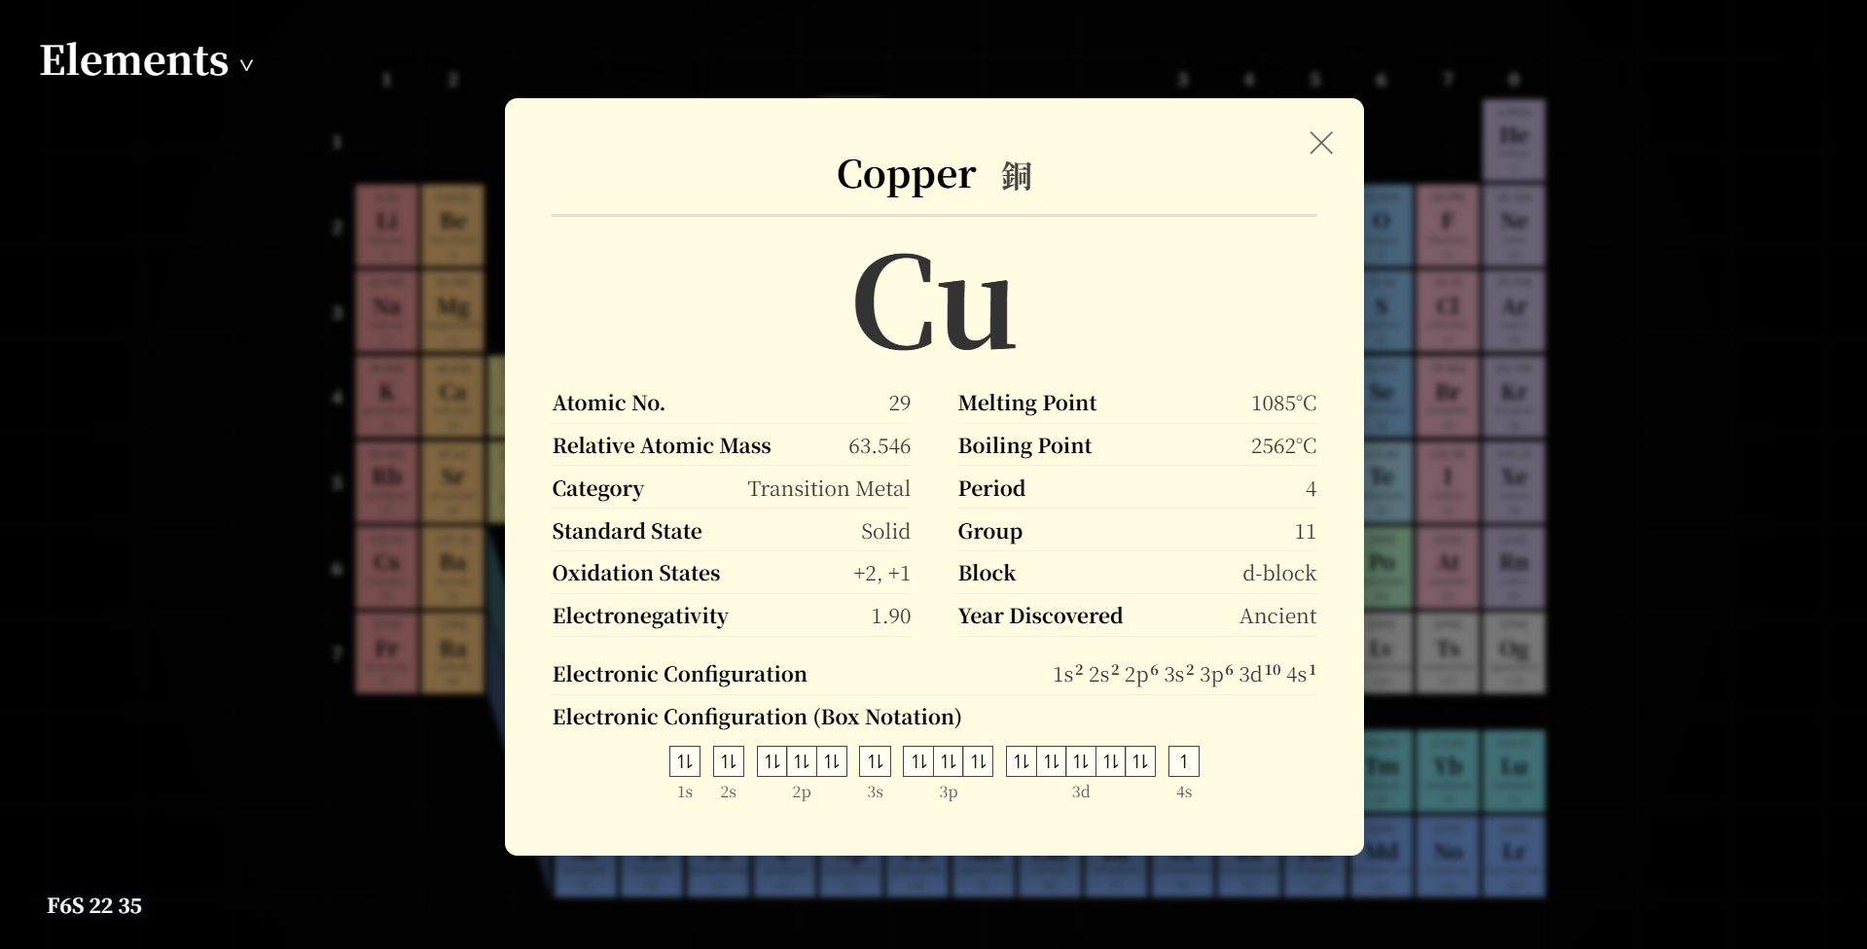

Screenshots (Equation Balancer)

